Session 7
READING CANDLESTICK CHARTS
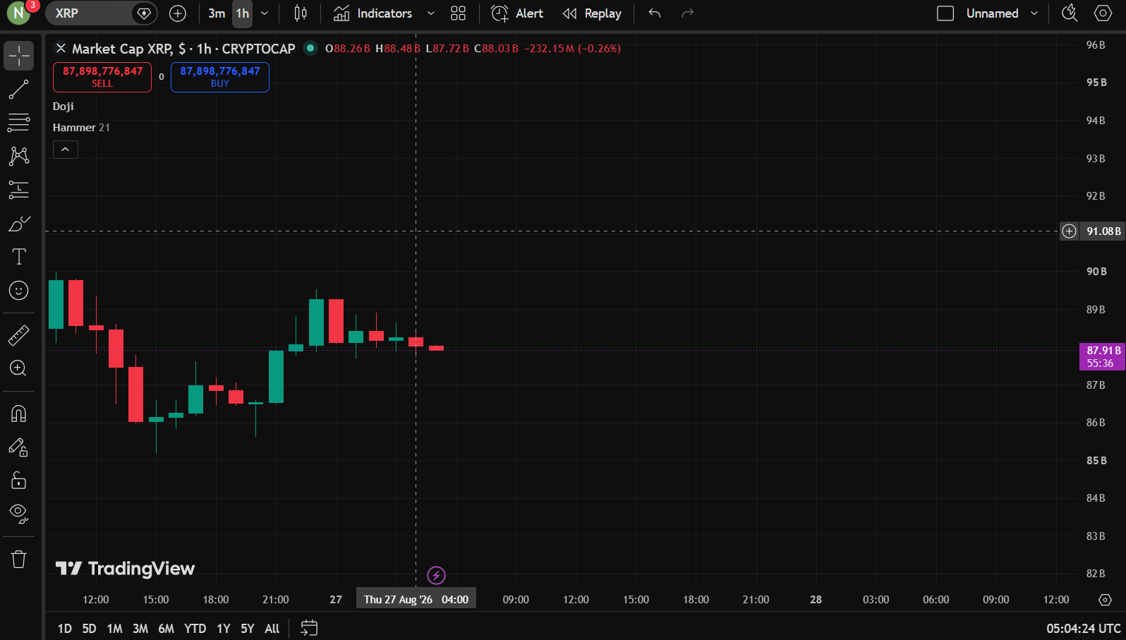

Candlestick Observation Report
Particular | Observation
Asset Name | XRP
Symbol | XRPUSD
Timeframe | 1 Hour(1h)
Number of Green Candles Observed | 10
Number of Red Candles Observed | 10
Doji Observed | Observed
Hammer Observed | Not Observed
Shooting Star Observed | Not Observed

Session 8
OBSERVING PRICE DIRECTION
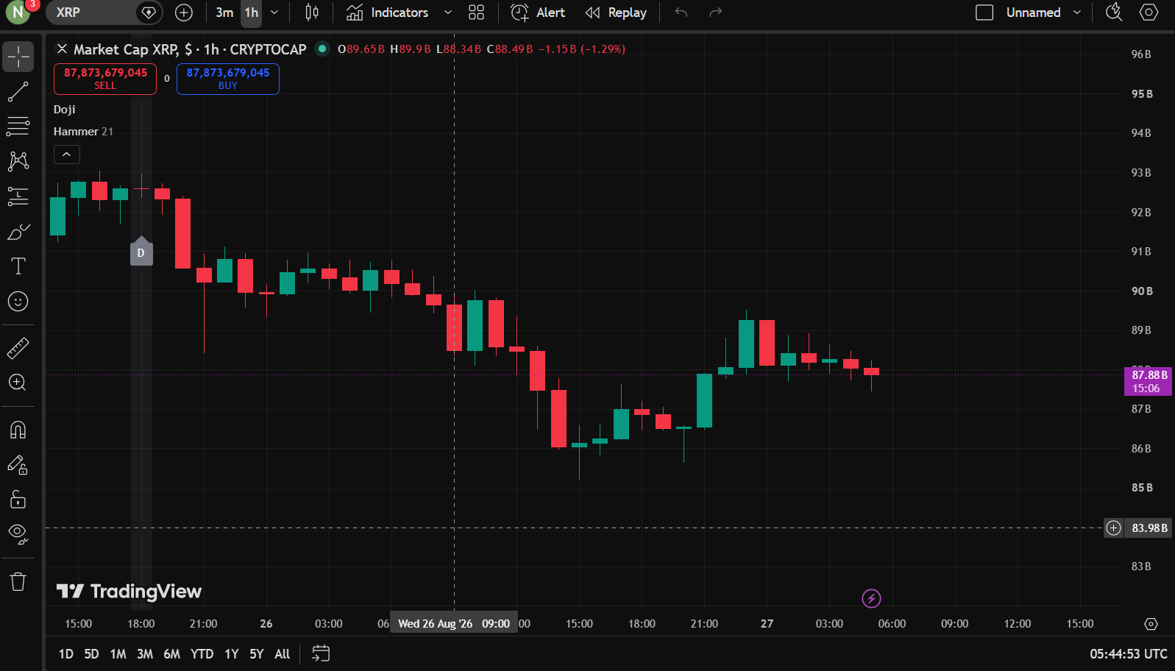

TREND OBSERVATION REPORT
Particular | Observation
Asset Name | XRP
Symbol | XRPUSD
Timeframe | 1 Hour(1h)
Trend Observed | Downtrend
Number of Candlesticks Observed | 40
Reason for Identifying the Trend | The chart shows a series of lower highs and lower lows,indicating an Downtrend

